To Withdraw an Agreement record:
In a complete Agreement record:
- Goto the More Actions Menu.
- Click on “Other Actions.”
- Choose “WITHDRAWN” from the dropdown menu.
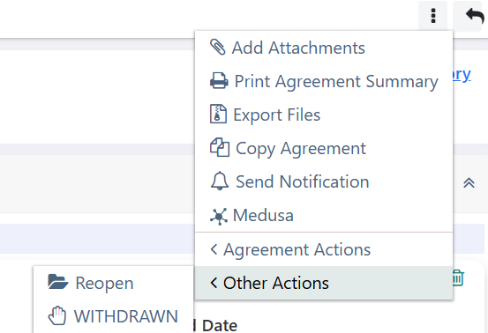
- Enter the reason for withdrawing in the Comment box.
Reasons include:
- Duplicate
- Not an Agreement
- PI/Dept Request
- Lack of timely response from other party
- Sponsor Notification
