Notice of Award (NOA) - Continuation (Amendment)
This guide covers the intake, triage, and review of new Notices of Award that are received by JH-RASP. For the purpose of this document, NOAs are defined as grants sponsored by NIH, NSF, and limited other sponsors.
These directions explain the concurrent roles and responsibilities of the NOA Specialist and RASP Contracts Associate/Grants Associate/Director.
Eawards Inbox and Intake
- NOA comes into eawards email inbox.
- NOA team adds NOA to NOA log for tracking purposes.
RASP NOA Team
- Triage to NOA team member for processing via email.
- Assigned NOA Specialist copies the document number from the NOA and searches in Oculus/ to determine SAP grant #.
SAP Grant # = Award # in Fibi.
Use the first award ending with –0001.
- NOA Specialist initiates New Agreement Request in Fibi. 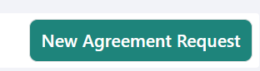
- NOA Specialist selects “Yes – This is a Modification of Funded Agreement” for the first triage question and links the SAP Award # in Fibi Agreement record to pull in award data. Triage should be answered as follows:
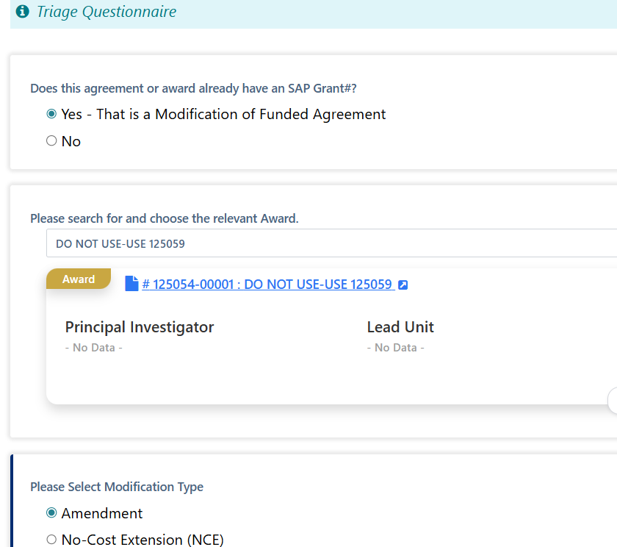
- Select “Amendment” for continuations and click “Save”.
- In a separate Fibi tab, locate the related RPPR Fibi Service Request (can search by linked SAP award # in SR – “Linked Record ID”). Download the SR Summary for use in the Agreement record.
- Link the Service Request to the Fibi Agreements record.
  - Click on Add Project Association.
  - Choose “Service Request” from the Module dropdown menu.
  - Choose Relation Type – “Related.”
  - Enter the SR# in the Choose Association field.
  - Click on Add Project Association.

Important: Do not click on “Resync & Replace Data” as this will erase linked personnel needed from the Award record.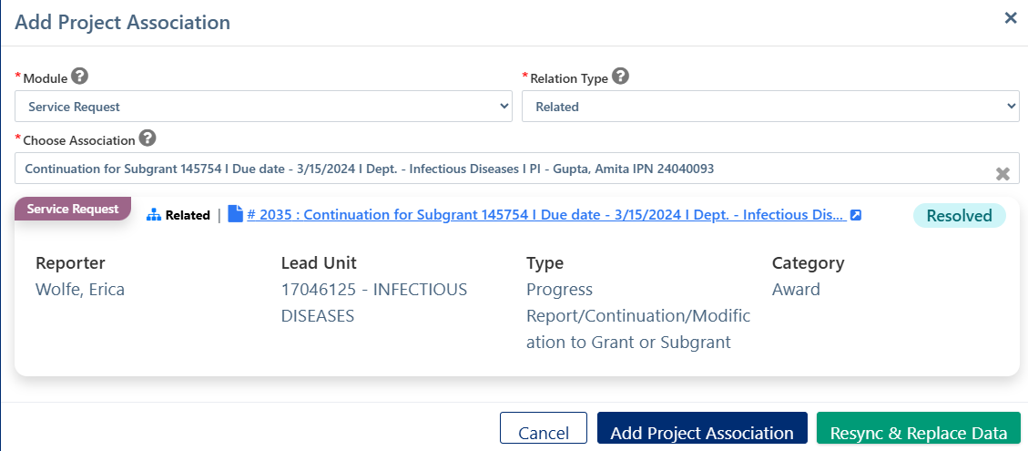

NOTE: If you click on the SR link in the Agreement record, the SR will now show the Agreement record in the SR.

- Update fields in Agreement record to match NOA, including the following on the Agreement tab:
- Type - Change to "NOA" if not already shown.
General Info > Type – Choose “NOA” from the dropdown menu.
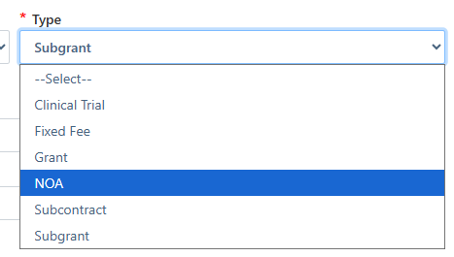
- Start & End Dates – Enter the budget dates for the start and end dates found on the NOA.
General Info > Start and End Dates – Enter the correct dates based on the NOA.
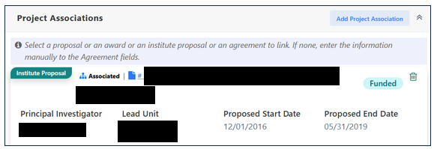
- Lead unit - Change to PI's Lead unit.
General Info > Lead Unit - Enter correct Lead Unit based on the Award record shown in the Project Association summary.
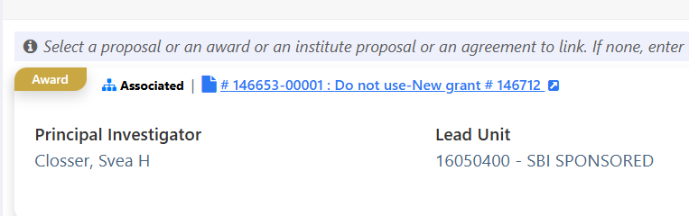
- Currency and Contract Value - Enter the award currency & award amount for current NOA action.
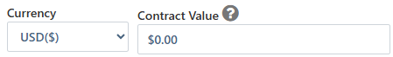
  - Choose “USD($)” from the Currency field dropdown menu.
  - Enter the Contract Value based on the NOA for the current action.
- Description - Add description of NOA (e.g. Career Development award, Fellowship, R01, etc.)
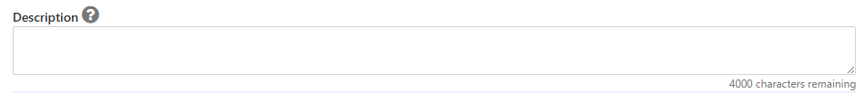
- Modification Type – Confirm the appropriate type from the dropdown.
Display should be, “Amendment.” If not, change the dropdown.
- Agreement origination question should be answered as “sponsor will provide the agreement”
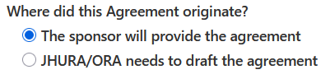
9. Add Sponsor information on the Agreement tab:
- Sponsor's Agreement ID # and/or (Ex. 1R01MH137795-02)
- Amendment # (only needed if continuation or revised NOA)
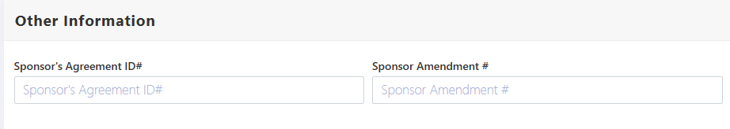
10. Confirm PI & Key Personnel in "People" section of Fibi Agreement record.
- CHECK personnel against Fibi PD record or PD Summary. PIs and Co-Investigators will display. 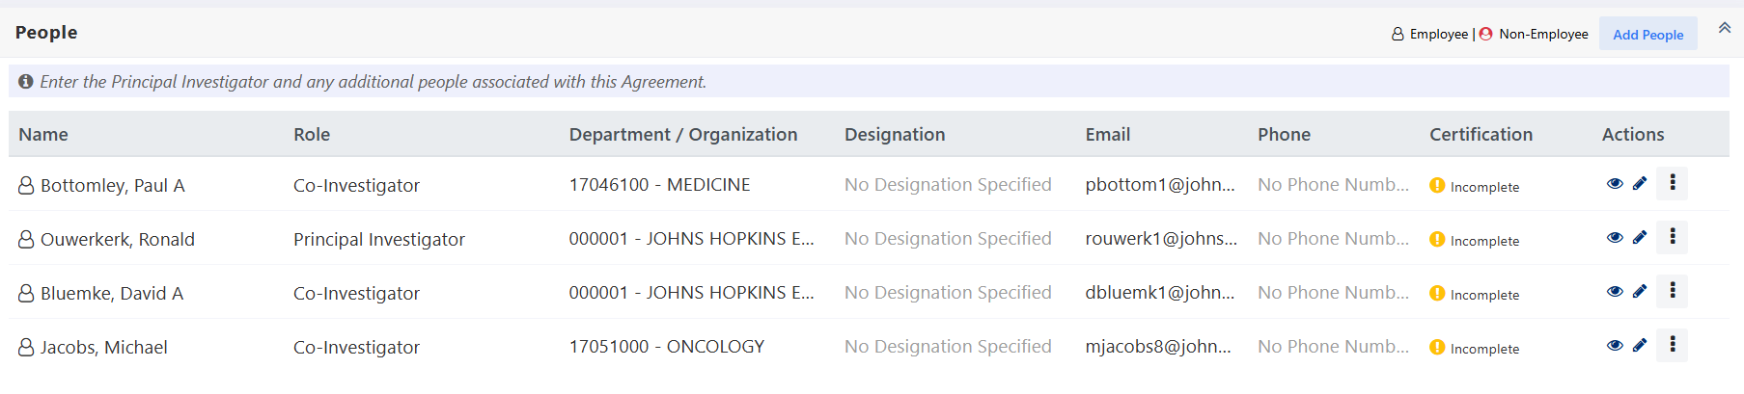
  - To add people, click on “Add People.”
  - To delete people, click on elipsis and choose “Delete.”
11. Update Sponsor Information
  - Add sponsor contact name & email (i.e. Grants Management Specialist name & email only).
    - Click on the icon. Enter all information and then click “Add Contact” button.
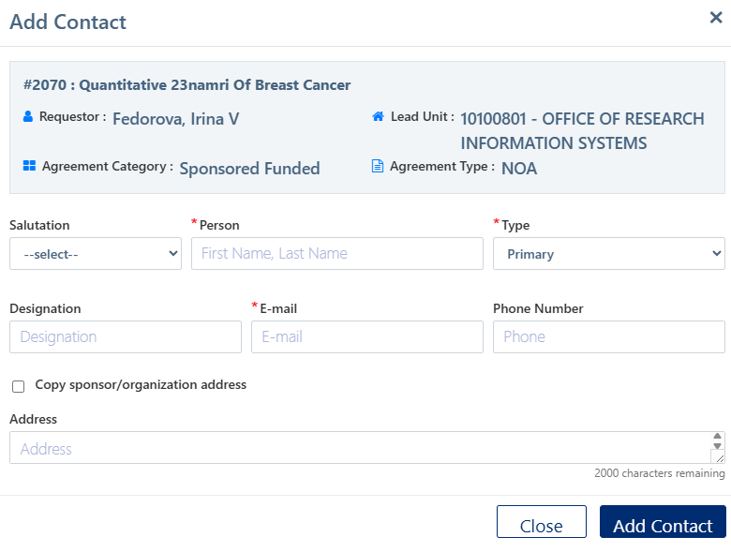
12. Check Special Review tab in IPN record & update Agreement record Special Review section, if needed.
NOTE: Protocol approval check happens later (during concurrent review)
13. Upload documents to Attachment tab:
- NOA
- Service Request (SR) Summary – Upload the Service Request summary to the Agreement record. This can be accomplished via the Downloaded Documents folder.
IMPORTANT NOTE:
For NOA Continuations, there should be no questionnaires on the Questionnaire tab. If one populates, please contact ORIS immediately.

14. Update Key Personnel certs on Certification tab (no actual changes, certs already completed in SR record).
- Click on pencil icon to change the status to “Completed.”
15. Submit record (status changes to RA Review in Progress).
- Click on “Submit Request” button.
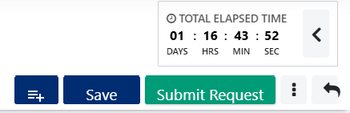
16. Review NOA terms and compare terms to Terms Cheat Sheet to determine if the NOA has additional or unusual terms.
If additional or unusual terms exist:
On Negotiation & Review tab, NOA Specialist assigns NOA record to applicable RASP CA/GA/Director for review.
- Click on “Add Review Location” button.
- Choose the appropriate Location from the dropdown menu.
- Enter the Assignee who will review the terms from the Contracts or Grants team.
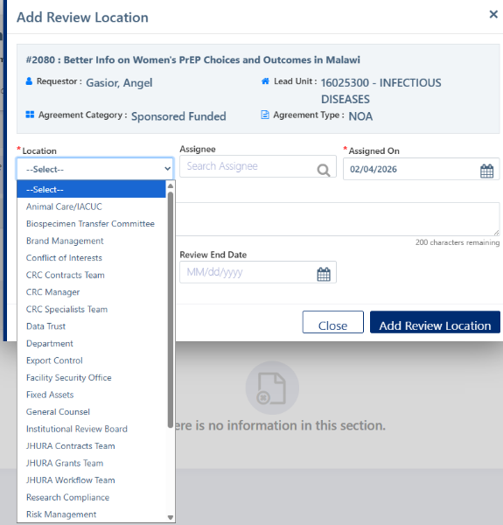
- Click on “Add Review Location” button.

If record is escalated for term review, the NOA Specialist continues to concurrent compliance review.
17. Complete compliance reviews:
- IRB/IACUC protocol check (correct protocol, approved and current)
- FCOI training
- Effort training
To search for Training completion dates:
- Click on the eye icon next to the person’s name. Then click on Training tab to see list of trainings taken.
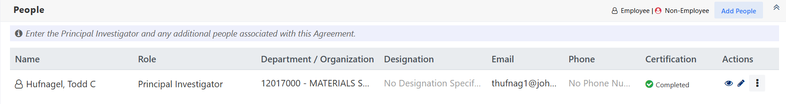
If compliance items are pending IRB/IACUC, incomplete trainings, etc., NOA Specialist requests missing compliance information:
  - Email department/division contact & requests missing/incomplete compliance pieces (e.g. pending protocols, incomplete trainings, etc.)
  - Add Review Location on the Negotiation & Review tab.
    - Click on “Add Review Location.”
    - Choose “Department” from the dropdown for the Location.
    - Add the Department Contact’s Name in Description.
    - Assignee should be the NOA Specialist’s Name.
    - Click on “Add Review Location” button.
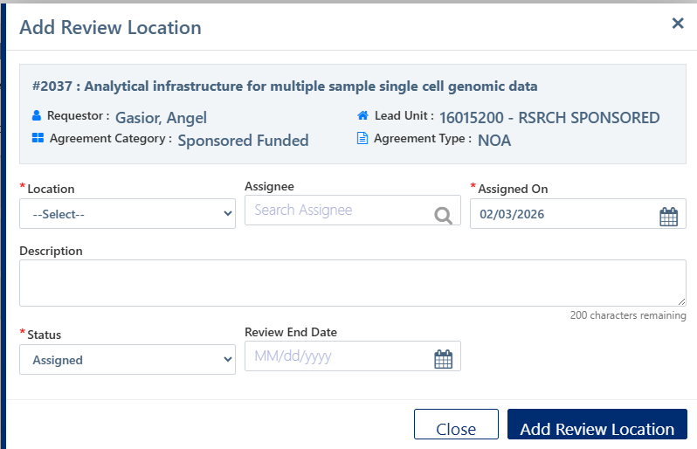
    - Update assignee status from “Assigned” to “In Progress” after email to department. is sent.
  - Add comments to Negotiation Activities (e.g. emailed ‘dept. person’s name’ for missing compliance)
    - Add Comment by clicking on icon next to “Department” Location.
    - Change Activity Type to “Email Sent/Received.” Enter Start date as the date email was sent.
    - Click on “Add Activity” button.
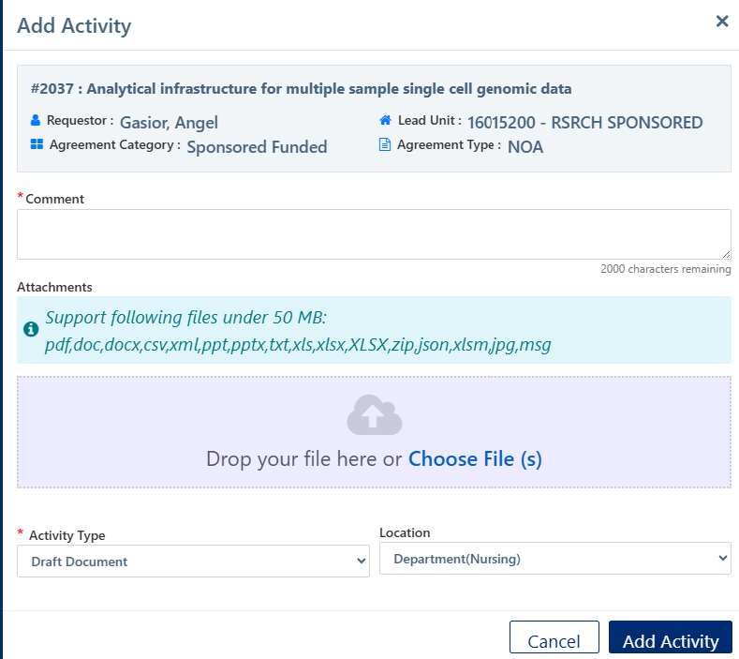
Example: 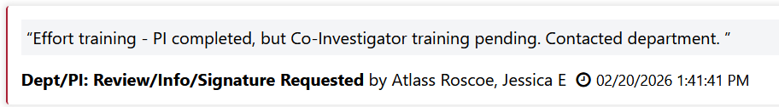

18. Add compliance check comments to Negotiation Activities notes (e.g. protocols approved, trainings completed?)
To add a Comment:
  - Click on  icon in line with your name.
  - Add Comment.
  - Change Activity Type to the appropriate choice in the dropdown menu.
NOTE:
Specialists can include multiple compliance check confirmations in one activity note, i.e. they do not have to create separate activity notes for each compliance review type if they are doing checks all at once.
Example:
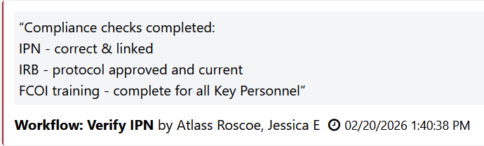

Directions for RASP CA/GA/Director Review
Specialist directions continue on page13.
If new or unusual terms exist:
- Receive email notification for the Fibi Agreement record.
- Open the record via the email link and changes their location assignment status to "In progress."
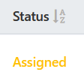
- On Negotiation & Review tab, click on ellipsis in line with your name and then choose “Start Review.”
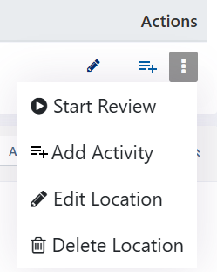
- Status will change to “In Progress.”
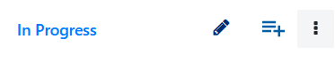
3. Review:
- Fibi Agreement record
- Visual compliance
4. Review NOA special terms.
If the special terms are not acceptable,
RASP CA/GA/Director adds an activity comment that NOA will be escalated (e.g. to OGC/Export Control) for further review & adds applicable Review Location to Negotiation & Review tab (e.g. Location: OGC).
- To add Comment:
  - Click on icon in line with your name.
  - Add Comment.
  - Upload email sent for further review (e.g. email to OGC/Export Control)
  - Change Activity Type to the appropriate choice in the dropdown menu.
- To add Review Location:
- Click on “Add Review Location” button.
- Choose appropriate Location from the dropdown menu.
- Enter the Assignee as your own name as other groups such as OGC do not use Fibi.
- Click on “Add Review Location” button. 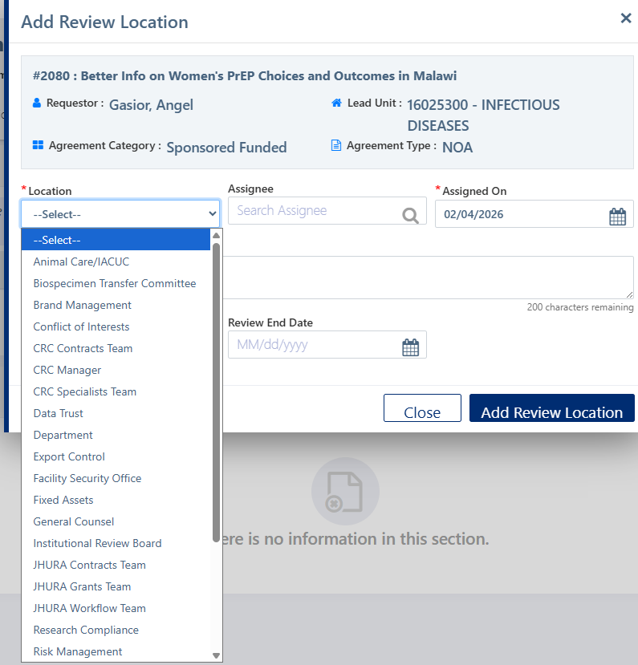

OGC reviews special NOA terms or Export Control review foreign entity & advises RASP CA/GA/Director on next steps.
RASP CA/GA/Director holds NOA record until approval by OGC and/or Export Control is confirmed.
Once terms have been determined acceptable,
    - Add an activity comment for NOA Specialist that terms are okay; workflow can proceed.
  - Click on icon in line with your name.
  - Add Comment.
  - Change Activity Type to the appropriate choice in the dropdown menu.
    - Update Location status to "Completed."
    - Click on ellipsis and change Status to “Completed.”
    - Enter Review End Date.
    - Click on “Update Review Location” button.
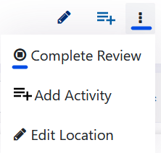
    - Update record status to "RA FEA."
- Click on Ellipsis > Agreement Actions > RA FEA.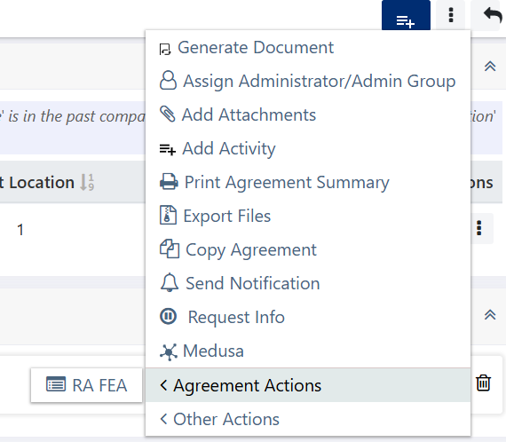
- Add document.
- Check Final contract document box.
- Click on Continue to RA FEA.
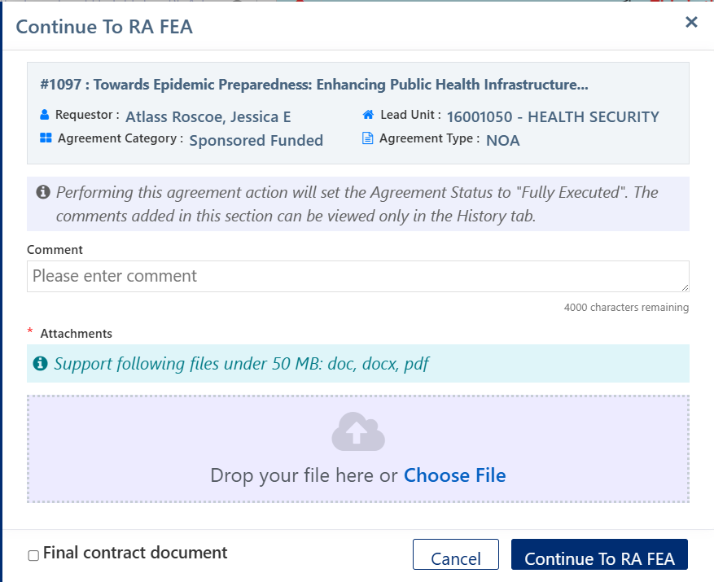

19. Once all compliance checks are completed & NOA terms okay, NOA Specialist uploads final NOA, and clicks "Final Contract document." If the agreement was also reviewed by GA/CA, this next step may be already completed.
Final contract box is only available when changing status to “RA FEA.”
- Click on the 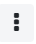More Actions Menu > Agreement Actions > RA FE.
- Add document.
- Check Final contract document box.
- Click on Continue to RA FEA.
Note: The Specialist can also replace the final agreement document on the Agreement tab.
- Click on the Version icon next to the Agreement Document.
- Drop in new version of the agreement.
- Check “Final contract document” box.
- Click on “Replace” button. 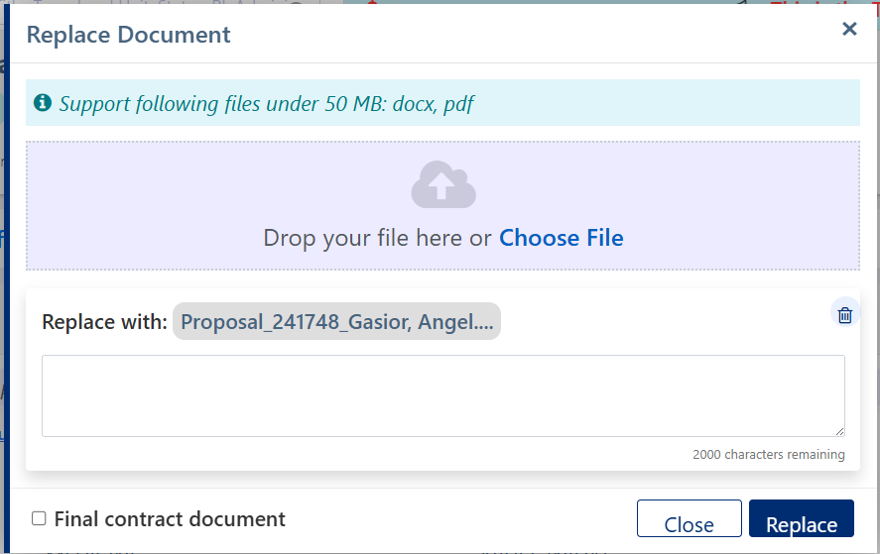

20. NOA Specialist updates the Financial tab information to match NOA (IDC rates & type), dates, and action amount.
    - Project Start and End Dates
    - F&A Rate Type
    - F&A Rate
    - Obligated Amount

If SPH lead unit, assign task to SPH in Negotiation and Review tab --> SPH workflow (same as NOA Specialist).
21. Prepare On Base package: Select applicable final documents, reorder (if necessary), and export to PDF (includes: NOA, RPPR SR Summary).
- Click on Ellipsis and choose “Export Files” from the menu.
- Click on Export to PDF.
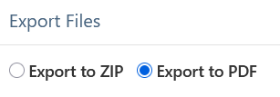
- Find uploaded NOA and SR Summary and check boxes.
- Scroll to the top of the list and click and drag into the following order:
  - Continuation NOA
  - RPPR SR Summary
22. Download Workflow PDF, upload & submit to SPSS via OnBase.
On the Attachments tab:
- Click on Download icon under Actions column.
- Open document and click on File > Save As and save to the location of your choice on your computer. [insert naming convention, if they same for SOM & JHURA]
- Upload file to Oculus/OnBase.
- SPSS notifies Dept (SOM) or Specialist (JHURA) of award setup/update via email
23. Update Fibi record status to "SPSS Transfer."
- Click on Ellipsis > Agreement Actions > SPSS Transfer
24. Update Fibi record status to "Complete."

